**Name:** Keyur patel

**Batch & Roll no:** A2-16010421073

**Tutorial Name and date-**Tut-1 and 2/2/2023

**Tu1-R1 Correlation & regression of lines (CO2)**

INSTRUCTION :Create a word file of the program using the following

|  |  |  |
| --- | --- | --- |
| Steps | Details | Marks (25) |
| 1 (on the top of page) | Name  Batch & Roll no  Tutorial Name and date | 1 |
| 2 | File name  R1-RollNo-Batch no_Name  Eg.  R1-16010421001-A1-TANUSHREE ACHARYA | 1 |
| 3 | Question1  Code on Rstudio  Output(print screen of all4 windows together) | 1  3  3 |
| 4 | Question2  Code on Rstudio  Output(print screen of all4 windows together) | 1  3  3 |
| 5 | Question3  Code on Rstudio  Output(print screen of all4 windows together) | 1  3  3 |
| 6 | Submission during tutorial time | 2 |

Q.1 Draw scatter diagram and determine the coefficient of correlation

|  |  |  |  |  |  |  |  |  |
| --- | --- | --- | --- | --- | --- | --- | --- | --- |
| Demand in quintals | 65 | 66 | 67 | 67 | 68 | 69 | 70 | 72 |
| Price in Rs Per kg | 67 | 68 | 69 | 68 | 72 | 72 | 68 | 71 |

**CODE**

x=c(65,66,67,67,68,69,70,72)

y=c(67,68,69,68,72,72,68,71)

r=cor(x,y)

plot(x,y,main="scatter diagram",xlab="Demand in quintals",ylab="Price in Rs Per kg")

cat("coefficient of correlation is",r)

paste("name, roll no. & Q.No", "Keyur Patel ,16010421073 & Q.1")

**OUTPUT**

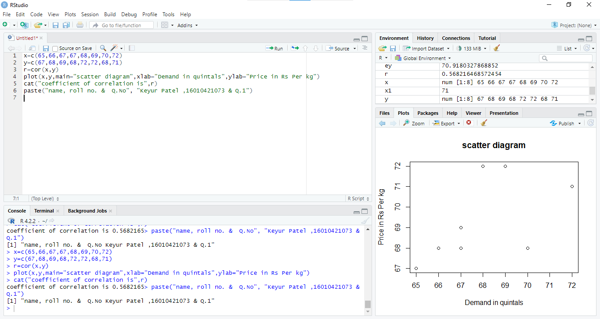

Q.2 Estimate the value of Y when X is 71

Plot equation of regression line of Y on X

|  |  |  |  |  |  |  |  |  |
| --- | --- | --- | --- | --- | --- | --- | --- | --- |
| Demand in quintals | 65 | 66 | 67 | 67 | 68 | 69 | 70 | 72 |
| Price in Rs per kg | 67 | 68 | 69 | 68 | 72 | 72 | 68 | 71 |

**CODE :**

x=c(65,66,67,67,68,69,70,72)

y=c(67,68,69,68,72,72,68,71)

r1=lm(y~x) # gives equation of of regression of y on x

co=coef(r1) # gives values of constants a,b in equation y=a+b*x

mco=matrix(co) # column matrix of constants a,b

a=mco[1,1]

cat ("constant term a is",a)

b=mco[2,1]

cat ("value of b is",b)

esty=fitted(r1) # gives estimated values of y for the given values of x

cat ("estimated values of y are", esty) # display estimated values of y for the given values of x

x1=71

ey=a+b*x1

cat ("estimated value of sale for year 71 is",ey)

plot (x,y,pch="+") # plots points corresponding to x and given value of y (+)

points(x,esty,pch="*") # plots points corresponding to x and it’s estimated value of y (*)

lines(x,y , col="green") # plots line corresponding to x and given value of y (+) using green colour

lines(x,esty , col="red")# plots line between x and estimated value of y (*) using red colour

paste("name & roll no", "Keyur Patel ,16010421073")

**OUTPUT**

**Constant terms a and b of regression line of y on x(i.e.y=a+bx) are 35.375 and 0.5**

**If X=71 then estimated value of Y is 70.875**

**R Studio Screen**

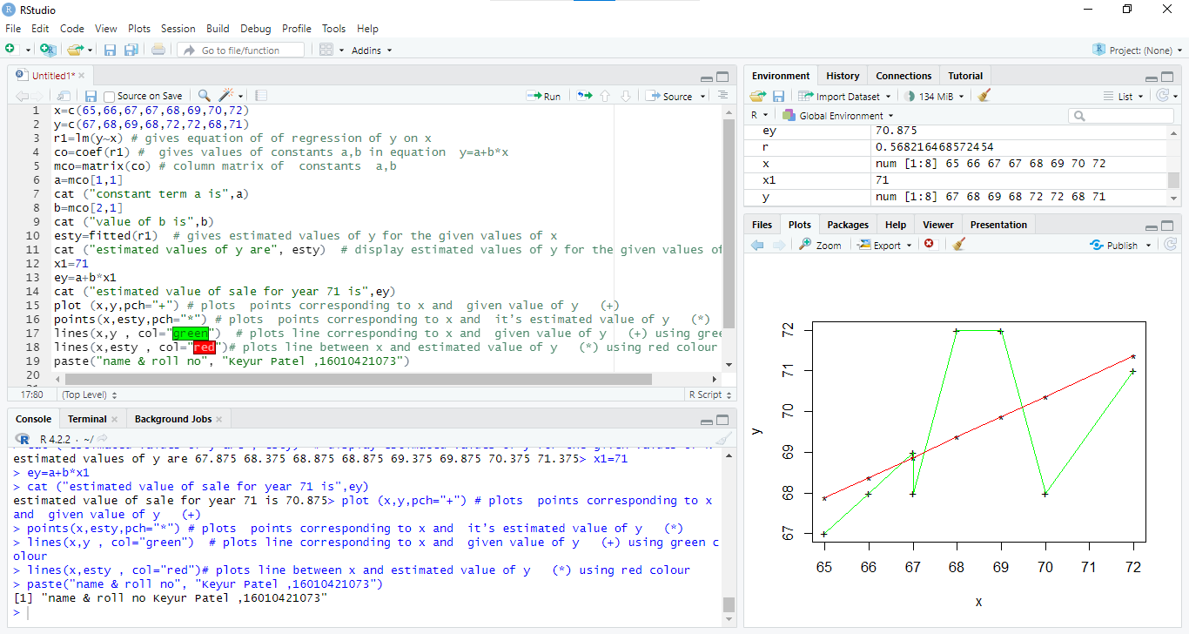

**Q3** Estimate the value of X when Y is 27

Plot equation of regression line of X on Y

|  |  |  |  |  |  |  |  |  |  |  |
| --- | --- | --- | --- | --- | --- | --- | --- | --- | --- | --- |
| x: | 23 | 27 | 28 | 29 | 30 | 31 | 33 | 35 | 36 | 39 |
| y: | 18 | 22 | 23 | 24 | 25 | 26 | 28 | 29 | 30 | 32 |

**CODE :**

x=c(23,27,28,29,30,31,33,35,36,39)

y=c(18,22,23,24,25,26,28,29,30,32)

r1=lm(x~y) # gives equation of of regression line of x on y(i.e.x=a+by)

co=coef(r1) # gives values of a,b

mco=matrix(co) # column matrix of a,b

a=mco[1,1]

cat ("constant term a is",a)

b=mco[2,1]

cat ("value of b is",b)

estx=fitted(r1) # gives estimated values of y for the given values of x

cat ("estimated values of x are", estx) # display estimated values of y for the given values of x

y1=27

ex=a+b*y1

cat ("estimated value of X is",ex)

plot (x,y,pch="+") # plots points corresponding to x and given value of y (+)

points(estx,y,pch="*") # plots points corresponding to x and it’s estimated value of y (*)

lines(x,y , col="green") # plots line corresponding to x and given value of y (+) using green colour

lines(estx,y , col="red")# plots line between y and estimated value of x (*) using red colour

paste("name & roll no", "Keyur Patel ,16010421073")

**OUTPUT**

**Constant terms a and b of regression line of x on y(i.e.x=a+by) are 2.116382 and 1.127767**

**If Y=27 then estimated value of X is** **32.5561**

**R Studio Screen**

